|  |
| --- |
| Blakely Games |
| ZombieMiner3.py |
| **[comp2069 – project #1B]** |
| Zombie Miner  Version #3.0.0  All work Copyright © 2013 by Blakely Games.  All rights reserved. |
| **Ryan Blakely** |
|  |



|  |
| --- |
| Aug 16th, 2013 |

**Table of Contents**

Version History ………………………………………………………………………………………………………..3

1. Game Overview ……………………………………………………………………………………………6
2. Controls ……………………………………………………………………………………………………….6
3. Screen Descriptions …………………………………………………………………………………….7
4. Levels ……..……………...…………………………………………………………………………………...10
5. Characters ……………...…………………………………………………………………………………...11
6. Enemies …..……………...…………………………………………………………………………………..11
7. Scoring …..……………...…….……………………………………………………………………………...12
8. Future Plans ..………...…….……………………………………………………………………………...12

**Version History**

**FULL VERSION HISTORY ON GITHUB:** [**https://github.com/blakely/zombieminer2**](https://github.com/blakely/zombieminer2)

**2.001 July 29,2013**

- Original game

- fow testing (drawFOW())

- handlePlayer/Zombies (moved code from game loop)

- testing various zombie collision logic change (clearing bag, resetting player pos, etc)

- added resetPlayer

**2.002 July 30,2013**

- added a second "type" of zombie...employs same logic and stats

- added centerpos constant for player instead of using startpos in scrollmap

- handleZombie changed to handle different zombie types

- more on handleZombie to check for sunlight before killing player. also stops zombie from moving

- fixed handleZombie bug where it wouldnt entirely reach the tile and die...this was fixed with the dirtyPos fix

- fixed resetPlayer bug where he could keep up after being reset (resets stepDist and act now)

- "pixel perfect" (uses exact position) vs getPos which uses tilebased posit

**2.003 July 30, 2013**

- Finally fixed that stupid bug where if a zombie was dying it would freeze up (seemingly) random other zombies

... the "continue" line in handleZombies, instead of having break there.

- added title to menu.png!

- fixed the winningTile bug where it couldnt be broken

- finally fixed a randomMapTemplate bug where it wasn't always making a full row of tiles (minor change in weighted random algorithm)

... added a default tile param

- fixed scrolling edge bug (not letting you go up and down at the right side)...just a matter of an X where there needed to be a Y

- changed up the fonts size and styles...gui doesnt entirely line up anymore, but im going to save that for the next iteration

- fixed startTime to display minutes and seconds when games done

**2.004 July 30, 2013**

- ...fixed dates. everything was june lol

- added a "fading vision" to the FOW drawing (drawVision)

- finished off FOW w/ player vision stat

- can now buy vision at shop

- MASSIVE gui changes. lots of moving/resizing of labels and buttons

- changed menu-to-game logic (game actually is started in menu now)

- implemented multiple levels of difficulty & menu for it

- implemented menu-to-menu logic (simple change menuWin)

**2.005 July 31st, 2013**

- slight gui changes - bolded stat font and changed the title font

- fixed slight bug where it wouldnt update the stat window if cash zombies hit him

- fixed bug where vision could still be bought at the store, even though there is no FOV

- can now "disable" buttons - disabling clicks and darkening the buttons image

...added changeBrightness(img,factor) to gameFunctions and also added a few related constants

- fixed a bug where nearby cash zombies would freeze if one was touching me

...the line returnWin = WIN_STAT fixed it, instead of instantly returning the window

**2.006 July 31st, 2013**

- changed setWinningTile to set handle a "random placement" flag. also setup appropriate constants

**2.006 Aug 1st, 2013**

- added game options dict to game() instead of multi-variables

- massive changes in gameConstants for zombie stats and game options to streamline different level creation w/ different zombies

..also some changes to how createZombies works (and how its called), and also the level-menu logic

..also some changes to setWinningTile to accept a given tile position instead of using the constant

- added dmg stat to miners based on strength to better regulate hit dmg

**2.006 Aug 2nd, 2013**

- made some changes to Window - no longer uses a drawPos, simply self.pos

- made some changes to labels to handle multi-line text

...this included major change to textImage in gameFunctions to handle multi-line text, since pygame doesnt natively support it

- first instruction window essentially complete. other windows should be easy with the above changes :D. done 006!

**2.007 Aug 2nd, 2013**

- templates for all of the instructions windows complete

- completely done main instruction window and mechanics window

- moved tileset up to the top as a constant as its needed for both game and menu (instruction screen)

...would do the same for zombies, but meh! someday

- added a bunch of constants for the instruction windows

- made some changes to Window - no longer uses a drawPos, simply self.pos

- made some changes to labels to handle multi-line text

- more changes to window to allow it to accept a list of images (Drawables) to contain aswell

- added function getTime in gameFunctions to handle seconds to minutes+seconds conversion

- moved mines win to a function because of all the code logic in creating it

- mines window complete! only zombies left

- finished the zombies screen! yay! all instructions screens are complete

**2.008 Aug 2nd, 2013**

- added "best time" functionality

...added 3 functions (bestTime,writeTimeFile,readTimeFile) and a few constants to maintain a "Best Times" (aka high score) file

...implemented logic to game loop to write best times

...added times window to main menu and a createTimesWin() function to create it

- moved times.dat (best times file) and above.dat (aboveground map file) to data folder

- all menu's now complete!

**2.009 Aug 5th, 2013**

- added some missing comments! also minor changes to tweak the games difficulty/fun-ness, mainly in Miners updateStats and to game constants

- added in some basic sounds (hitting, breaking, shopping) added necessary constants

- last minute fix...have to check for stat type before multuiplying zombie stats based on random pos

**2.010 Aug 14th, 2013**

- serious changes to scrollMap...i dont know what i was even thinking before. function requires way less parameters and totally different logic

also had to make a small change in gameObjects to TileMap.move so self.shift isnt cumulatative

- planning to add a "ghost"-zombie that can move through diggable tiles. added to tryAction an "ignore tiles - just move" flag for the ghost

- made a tilemap.randomPos to generate random positions for the zombie creation, teleporting, and winning tile (done). in the midst of integrating it throughout - almost done!

- teleport() now takes the tilemap and tileset to be able to replace tiles if they are diggable...so people dont get placed ontop of tiles

- fixed tilemap.randomPos to work better, regenerating positions until its a "good" one (not blocked, not winning, after start pos)

...as such, startPos isn't really needded but i will leave it there for future mods, just incase. i foresee it being useful.

- added an inRange() function and a constant ZOMBIE_AI_RANGE, as well as some new logic in handleZombies to try and curb zombie trains.

...zombies should only chase after the player if they are within range of the player.

- added addtional constants for the "extreme" difficulty with ghost-zombies

- had to make a change to how tilemap.move handles maximum bounds - it was bugged after the change to scrollMap

- 1 last minor tweak to tilemap.randomPos...was some bad logic. Also commented out "inRange" in handleZombies for testing. will uncomment on next iteration

**2.011 Aug 15th, 2013**

- more mods to randomPos (more bad logic. and where there should be an or). was placing zombies specifically on blocked tiles isntead of avoiding them:P

- more changes to how scrollMap tilemap.move works (+1 param) so there is no clipping at maximum map edges

- renamed "strength" to "power" in the GUI to conserve space. redid some of createStatWin to show player Hp and added an HP constant

- zombies now minus HP from player, and player dies when HP=0. HP is fully implemented at this point

- major sound updates. added several constants and 2 functions to gameFunctions to play sounds and control (fade in and out) ingame music

...also added several sounds at new events and implemented the entire "music" system for the game

**2.012 Aug 15th, 2013**

- splash screen done. added a function (splash()) with a delay to display it for

- revamped zombies and zombie-type logic (different actions when hitting player)

- redid a bunch of constants and spacing for the windows to add new ghost zombie (particularly HOW_ZOMBIES_WIN)

- to do:FIX CONSTANTS FOR REAL GAME!!!

BETTER AI!!!

- minor sound bug fix...for some reason Sound.get_raw() doesn't exist anymore?? maybe I had on older pygame installed

... at any rate, replaced with get_length(). This could pose problems if the lengths match,but that seems unlikely for now :

**3.012 Aug 16th, 2013**

- officially version 3.0. changing to zombieminer3.py

- FULL SCREEEEEEN!!!!!

1. **Game Overview**

**A mining game…with zombies!**

*ZombieMiner2.py (Zombie Miner) is a simple mining game in which the player must obtain their stolen meth located somewhere in a zombie-infested cave. In order to do so, the player must navigate their way through the cave while collecting other precious gems that they may sell at the shop in order to purchase better stats (such as Power, Speed, and Vision) and also avoiding obstacles (rocks) and possible enemies. When the player breaks mine-blocks that have precious gems, the gems will be added to the players’ bag – unless of course the players bag is full!*

*To win the game, the player must find and excavate the stolen meth.*

*While navigating the mine, the player may encounter Zombie miners (the enemies!), to which the player should not interact with. If a zombie catches the player, the player will suffer damage as well as other various setbacks such as losing what they have stored in their bag, being teleported back to the shop, etc.*

*The game is lost when the players life-count (HP) reaches 0.*

*In order to destroy the zombies, the player must lead them out into the sunlight, at which point the zombie will burn and perish. As the zombies are burning, they are unable to harm the player. Zombies will only follow the player if they are within range of him/her (the range is roughly the size of the screen).*

*There are four main difficulties (Easy, Medium, Hard, Extreme) with varying numbers and types of zombies, along with a Free-Play option in which there are no enemies whatsoever. Depending on which difficulty is selected, the game may have a "Fog of War" effect in place, not allowing the player to see far within the cave without purchasing additional Vision from the store. Meth placement also depends on the difficulty selected.*

1. **Controls**

* *Standard keyboard arrow-controls for player movement*
  + ***Left-arrow:*** *Left*
  + ***Right-arrow:*** *Right*
  + ***Up-arrow:*** *Up*
  + ***Down-arrow:*** *Down*
* *Mouse-click controls for buying stats & menu functionality*
* *Walking into “dig-able” tiles will result in the character digging.*

1. **Screen Descriptions:**

***Splash Screen: Startup screen:***

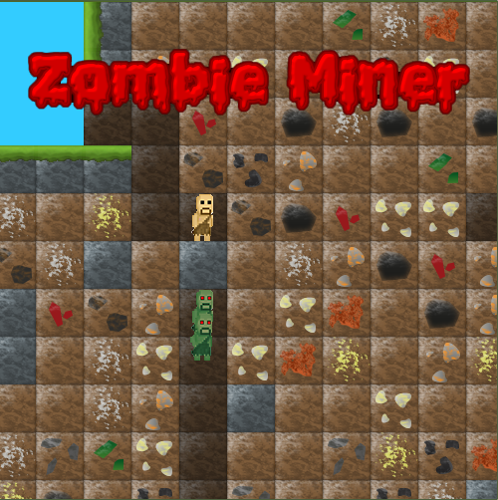 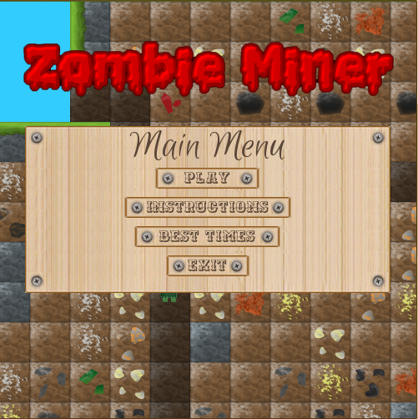

***Game Overview (1st instruction) screen: Zombie Screen (3rd instruction) screen:***

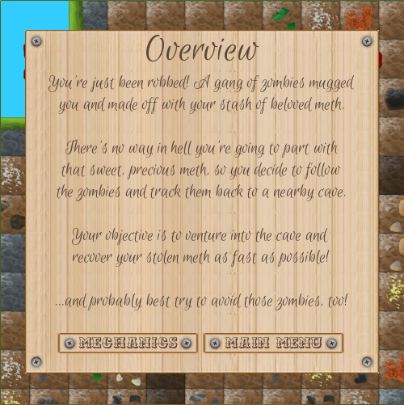 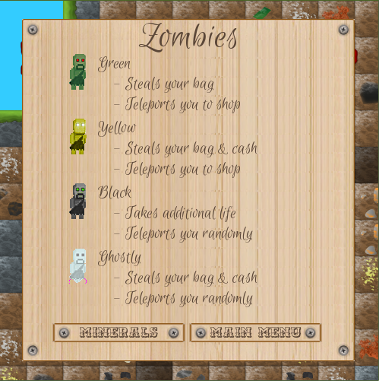

***Mineral description screen: Best times (high score) screen:***

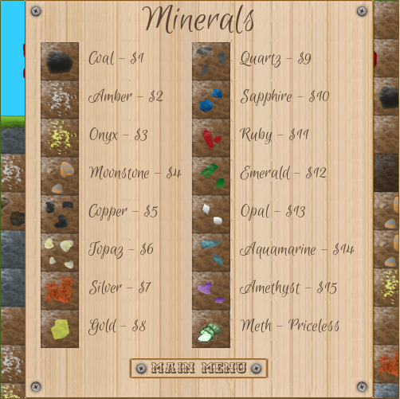 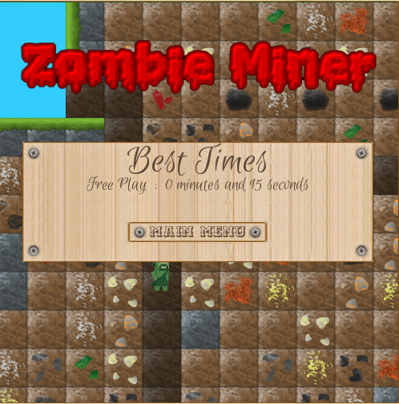

***Free-Play difficulty (deep in Mine): Easy Difficulty (with a zombie):***

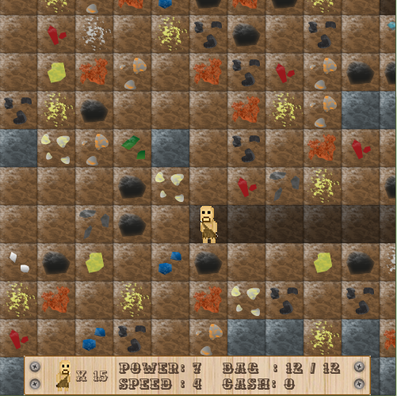 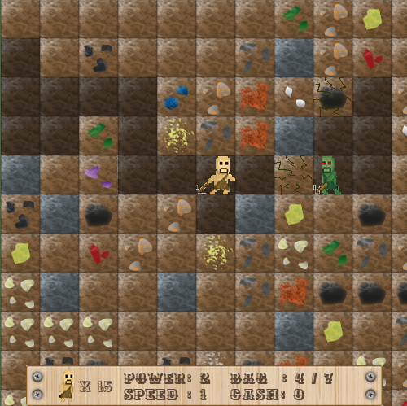

***Easy Difficulty (with the shop): Medium Difficulty (with burning zombie):***

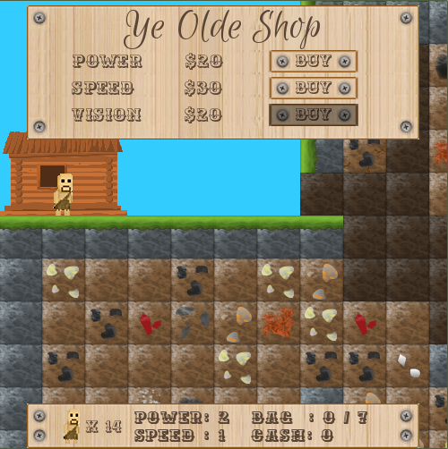 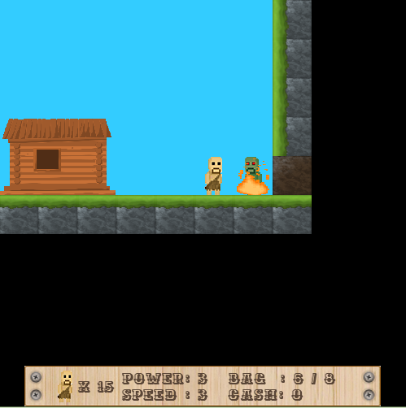

***Hard Difficulty (with Fog of War): Extreme Difficulty (with “ghost” zombie):***

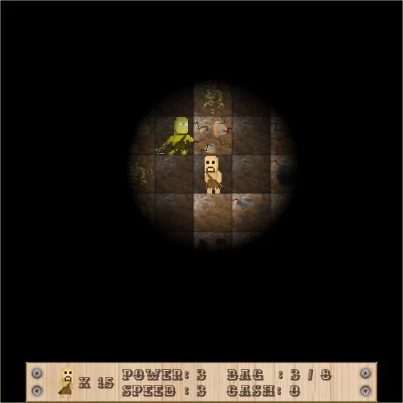 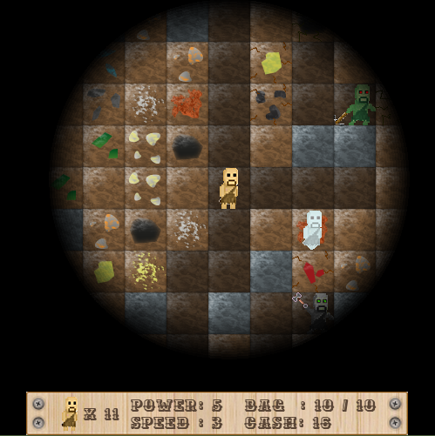

***Winning game screen: Game over screen:***

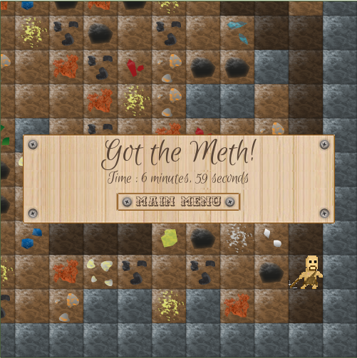 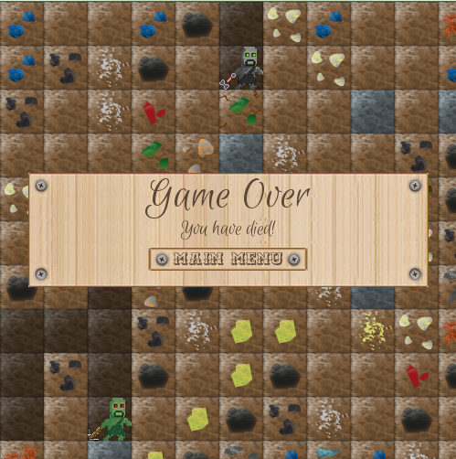

1. **Levels**

*There are five levels of difficulty that the player can choose from:*

* ***Free Play:*** 
  + *No zombies.*
  + *No Fog of War.*
  + *Meth in bottom-right corner.*
  + *Small map*
* ***Easy:*** 
  + *Green zombies.*
  + *No Fog of War.*
  + *Meth placed randomly on bottom row.*
  + *Small map*
* ***Medium:*** 
  + *Green & yellow zombies*
  + *Fog of War.*
  + *Meth randomly placed on bottom row.*
  + *Medium map*
* ***Hard:*** 
  + *Green, yellow & black zombies*
  + *Fog of War.*
  + *Meth randomly placed.*
  + *Medium map*
* ***Extreme:***
  + *Green, yellow, black & ghost zombies.*
  + *Fog of War*
  + *Meth randomly placed.*
  + *Large map.*
  + *EXTREMELY HARD*

1. **Characters**

*The character played by the user is a Miner (though it more closely resembles a caveman). The character has the ability to move freely within the limits of physics (which do not apply in the mine itself), and also has the ability to “pick” at mineable tiles within the games Map. Both actions are animated accordingly.*

*The player has 3 stats (only 2 on Free Play and Easy):*

*-* ***Power:*** *The amount of damage a player does per hit, and the bags max capacity.*

*-* ***Speed:*** *How fast the player moves and hits.*

*-* ***Vision:*** *How far the player can see within the Fog of War.*

1. **Enemies**

*There are 4 enemies in total. Each level of difficulty (sans Free Play) adds a new type of zombie.* ***All zombies do atleast 1 damage when colliding with the character.***

*The 4 types of zombies are:*

* ***Green:***
  + *Steals the players bag*
  + *Teleports player to the shop*
* ***Yellow:***
  + *Steals the players bag*
  + *Steals the players money*
  + *Teleports player to the shop*
* ***Black:***
  + *Steals the players bag*
  + *Teleports player to random location on the map*
* ***Extreme:***
  + ***Can walk through “dig-able” tiles (not rocks)***
  + *Steals the players bag*
  + *Steals the players money*
  + *Does 1 additional damage to player*
  + *Teleports player to home*

1. **Scoring**

*Scoring for Zombie Miner is very simple. The scoring is based on the fastest finishing time (fastest player to reach the meth), and each level of difficulty has its own best time. The best times for all 4 levels of difficulty can be viewed from the Main Menu, and are stored in a file called* times.dat *in the* ../data/ *directory*

*(times.dat - records are of form “Easy=3235” where “Easy” is the level and “3235” is the best time in that level in seconds. 1 record per line.)*

1. **Future Plans**

* *Better game balance. Difficulties don’t necessarily scale as they should.*
* *Better pathfinding algorithm for AI.*
* *Chests to find in the cave*
* *Torches to place in the cave for constant lighting*
* *Music/sound on/off functionality.*